__________________________________________________________
EMORY UNIVERSITY SCHOOL OF MEDICINE

DEPARTMENT OF CELL BIOLOGY

__________________________________________________________

“Modeling mental disorders with patient-specific induced pluripotent stem cells (iPSCs)”

Presented by

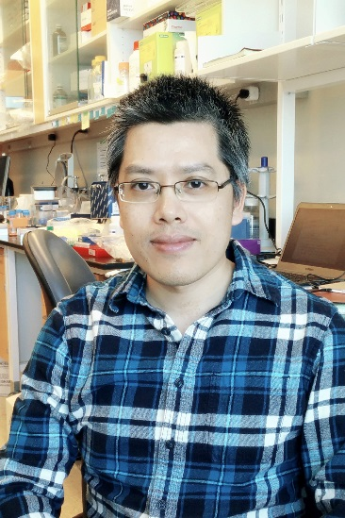

Zhexing Wen, Ph.D.

Department of Neurology
Institute for Cell Engineering
Johns Hopkins University School of Medicine

Wednesday, March 30, 2016
4:00PM
Whitehead Biomedical Research Building, Room 400

Light Refreshments served at 3:45 PM

